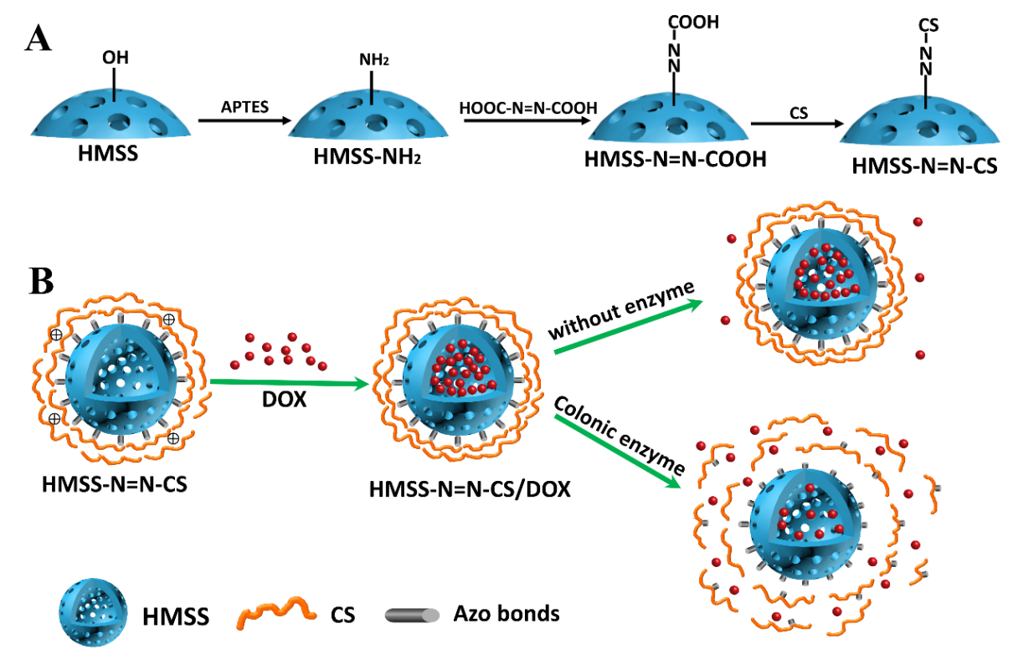
Scheme. 1 Schematic illustration of (A) preparation process of HMSS-N=N-CS and (B) the drug loading and enzyme-responsive release of HMSS-N=N-CS/DOX in response to colon enzyme.

